Paylocity, Change of Last Name to First Name.

Bug description:
As a final user I would like to Add/Update an employee with the correct First and Last Name.
The tool is currently storing the First Name as the Last Name and the Last Name as the First Name of the new employee; It can be reflected in the main grid.

Steps to reproduce the issue:
1.-Log in to Paylocity tool.
2.- Once you are on the Paylocity Benefits Dashboard, click on:
Add Employee Button.
Update Icon in Actions column.
3.- A popup will appear, type the data of the employee to be added/updated; (Example
First Name: Juan; Lat Name: Perez; Dependents:1)
4.- Click on
Add Button.
Update Button
Expected Results:
The introduced data should appear correctly in the grid. (The first name should be displayed in the First Name column, and the Last Name should appear in the Last Name Column)
Actual Results:
The introduced data appears incorrectly in the grid. (The First Name is displayed in the Last Name column, and the Last Name is displayed in the First Name Column)
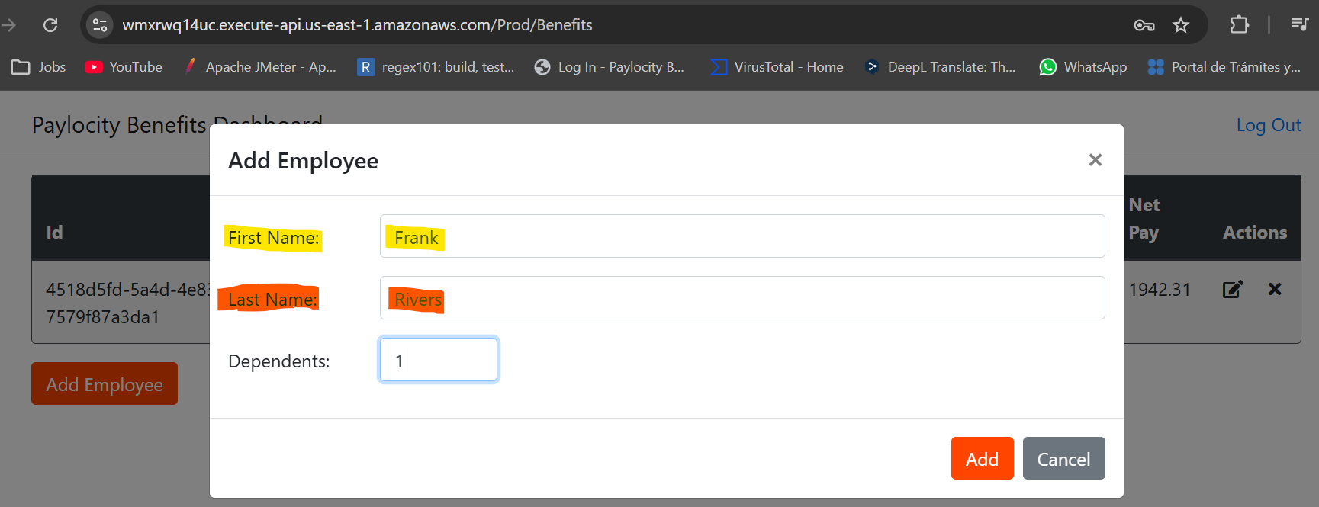
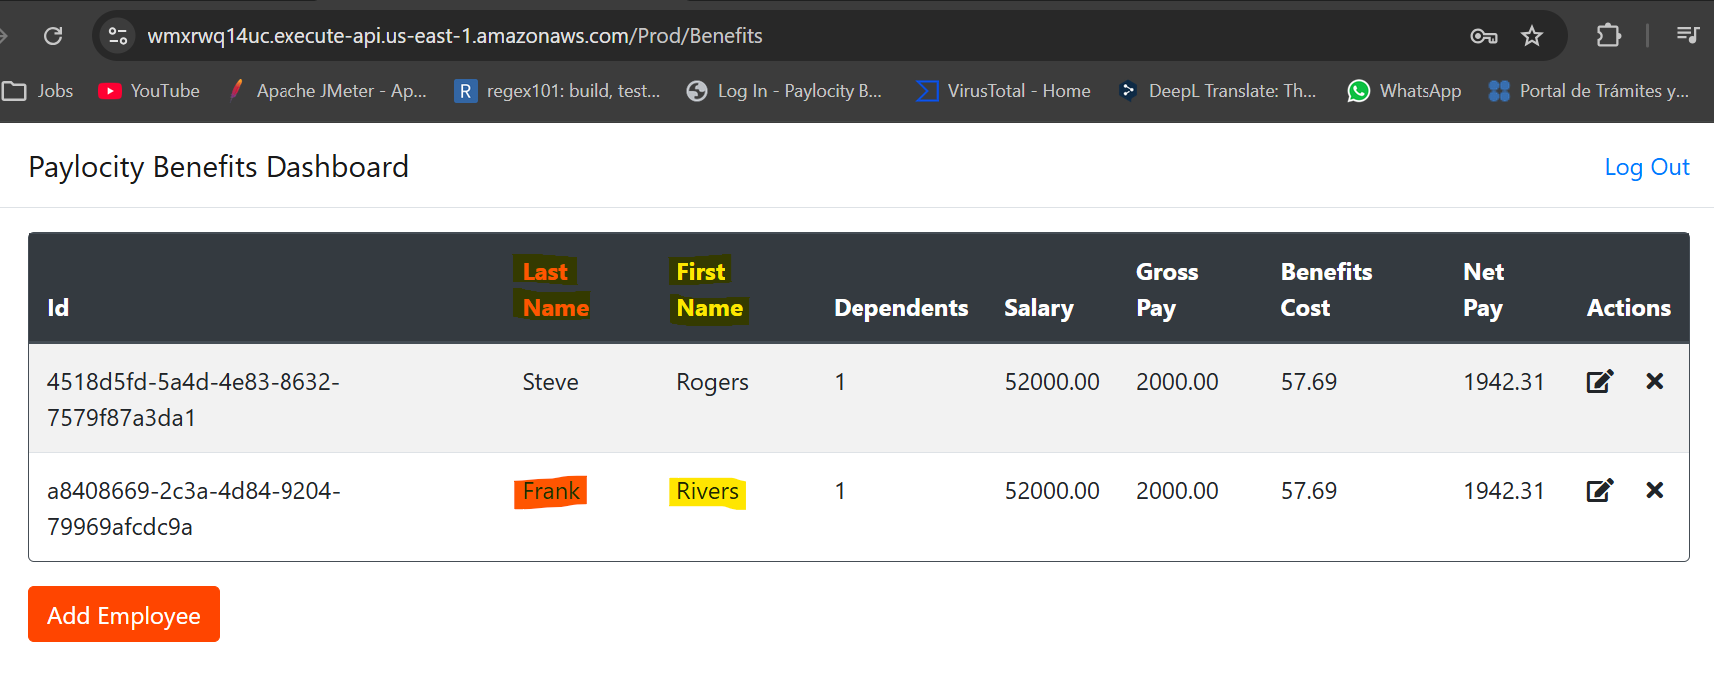

++++++++++++++++++++++++++++++++++++++++++++++++++++++++++++++++++
Paylocity Adding an employee (Duplicate Employees)

Bug description:
The tool allows users to add employees with the same first and last names as existing ones, even if the ID is different, which allows for the possibility of user errors during the review of the information.

Steps to reproduce the issue:
1.- Log in to Paylocity tool.
2.- Once you are on the Paylocity Benefits Dashboard, click on Add Employee Button.
3.- A popup will appear, type the data of the employee to be added; (Add an existing employee.)
4.- Click on Add Button.

Expected Results:
This new employee should NOT be added.
A warning Should be displayed, (This is an existing employee).
You should be able to add a mark to differentiate employees. (A number for example).
Actual Results:
The employee is added.
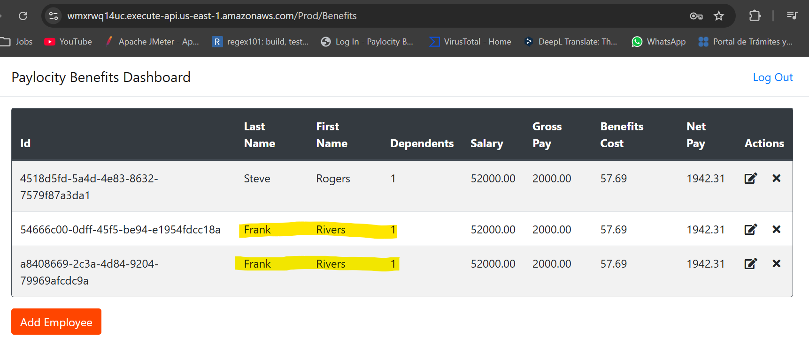
++++++++++++++++++++++++++++++++++++++++++++++++++++++++++++++++++++++++

Paylocity, There is NOT any warning displayed.

Bug description:
As a final user I would like to see any guide to help me to understand why my employees is NOT Added/Updated.

Steps to reproduce the issue:
1.- Log in to Paylocity tool.
2.- Once you are on the Paylocity Benefits Dashboard, click on
Add Employee Button.
Update icon.
3.- A popup will appear, type the data of the employee to be added/updated.
-Leave at least one Text Box in blank (First name, Last name, Dependents).
-Type a number greater than 32 in Dependent Text Box.
-Type any character (especial character, numbers and letters) in any text box.
4.- Click on Add/Update Button.

Expected Results:
Leaving at least one Text Box in blank
A warning popup should be displayed “It is necessary to fill all blank spaces”.
Typing a Number greater than 32 in Dependents
A warning popup should be displayed “You can NOT add more than 32 Dependents per employee ”
Type any character (especial character, numbers and letters) in any text box.
Valid example data (First and Last Name): Juan Pérez1, Juan Pérez2, Antonio Bautista 3.
The employee should be Added/Updated.
Invalid example data (First and Last Name): ¡”#Juan Pérez, “#498 Ramírez.
A warning popup should be displayed “You can NOT Introduce special characters”
Valid Data (Dependents): positive integers from 0 to 32.
The employee should be Added/Updated.
Invalid example Data (Dependents): Fractional numbers, Letters and special characters.
A warning popup should be displayed “You can NOT Introduce special characters”

Actual results:
Leaving at least one Text Box in blank
Nothing is happening, there is NOT a message/warning displayed to guide the user to understand what is going on.
Typing a Number greater than 32 in Dependents
Nothing is happening, there is NOT a message/warning displayed to guide the user to understand what is going on.
Type any character (especial character, numbers and letters) in any text box.
Invalid example data (First and Last Name):
Nothing is happening, there is NOT a message/warning displayed to guide the user to understand what is going on.
Invalid example Data (Dependents):
Typing a letter/special character after a valid number.
The employee is stored and shown in the grid (It does not consider the character after the number).
Typing a fractional number (1.5 for example).
The employee is stored and shown in the grid (It only considers the number before the point).
Typing only letters or special characters.
Nothing is happening, there is NOT a message/warning displayed to guide the user to understand what is going on.
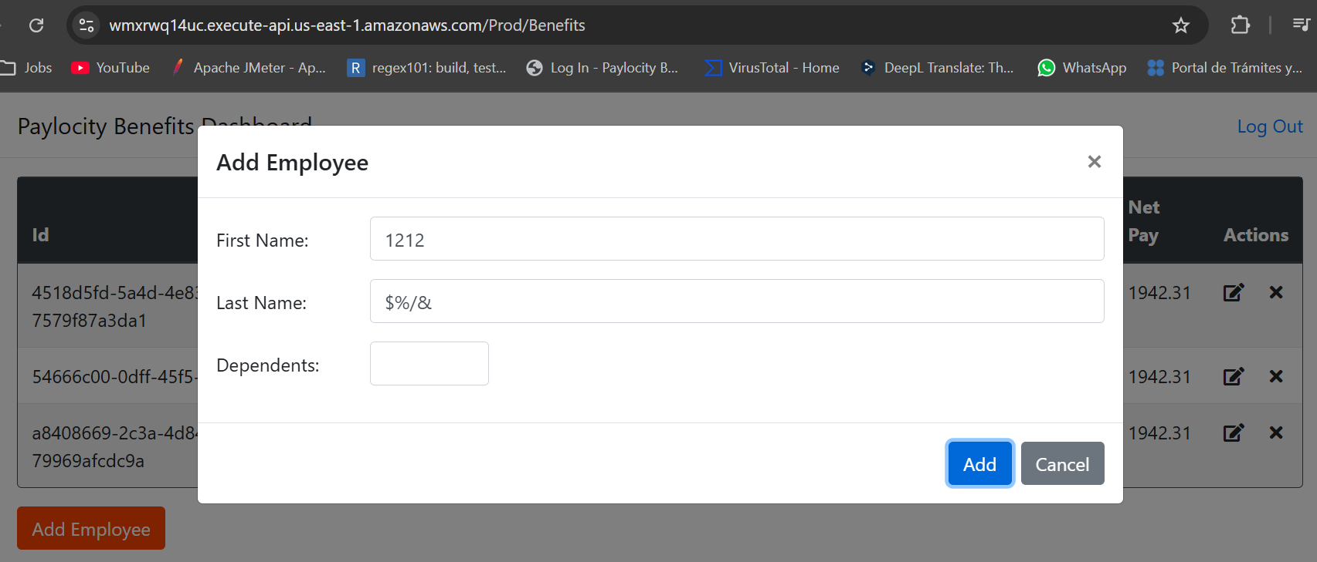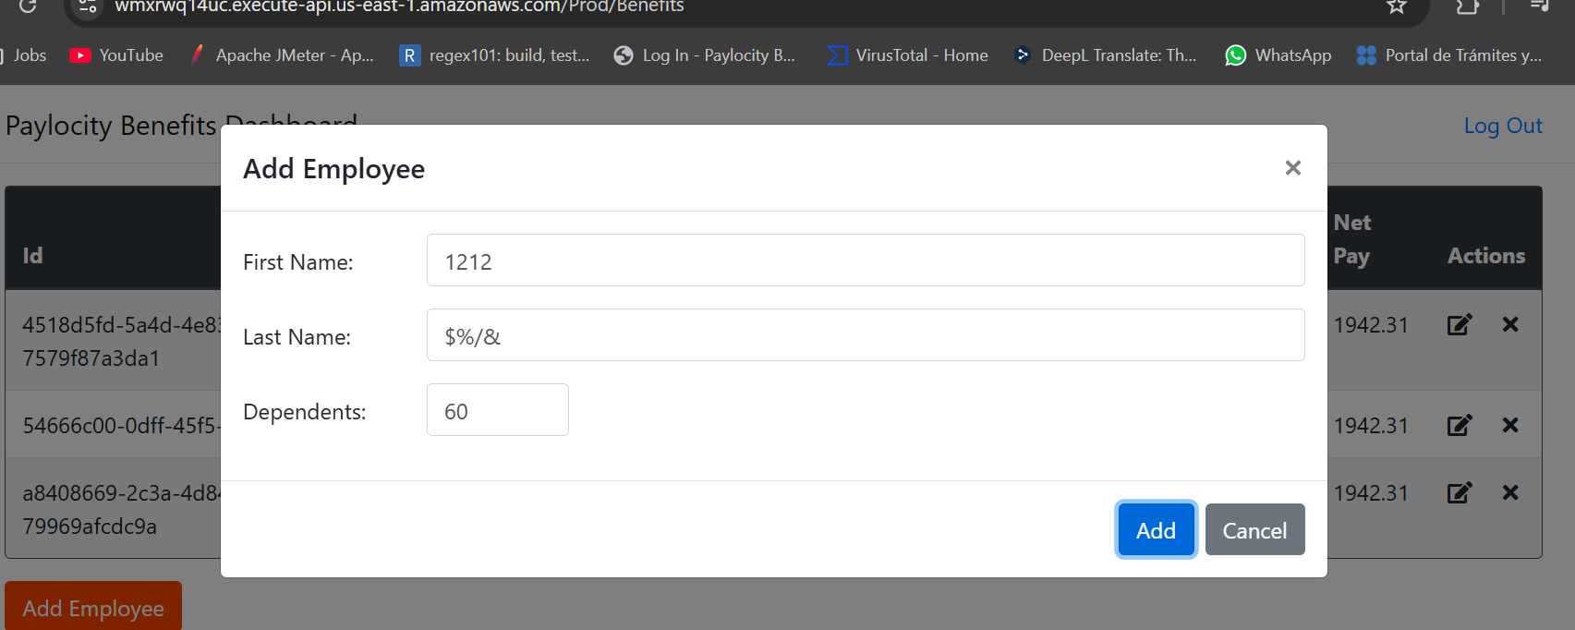
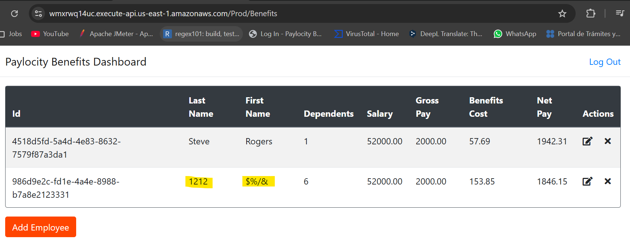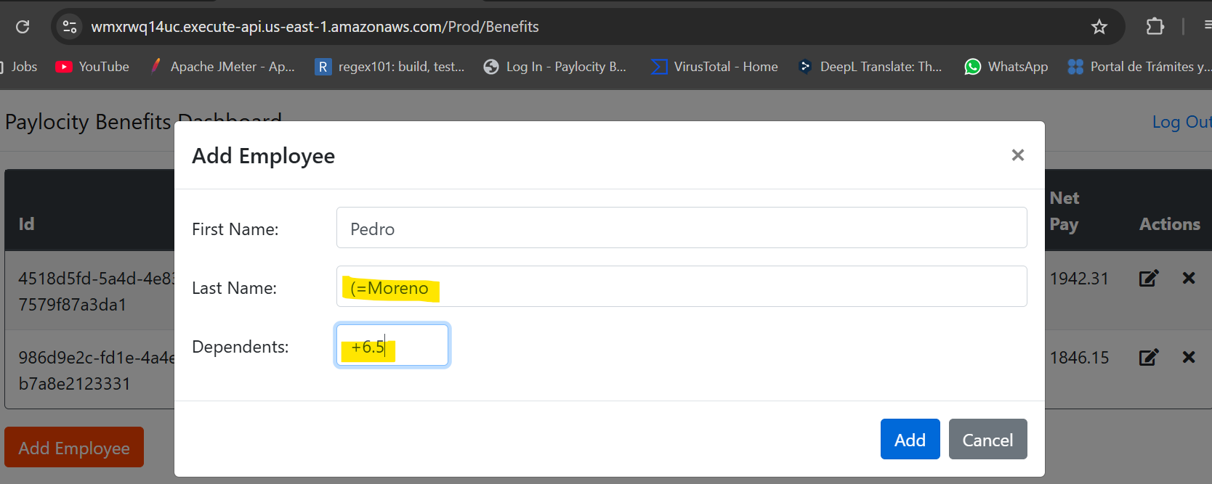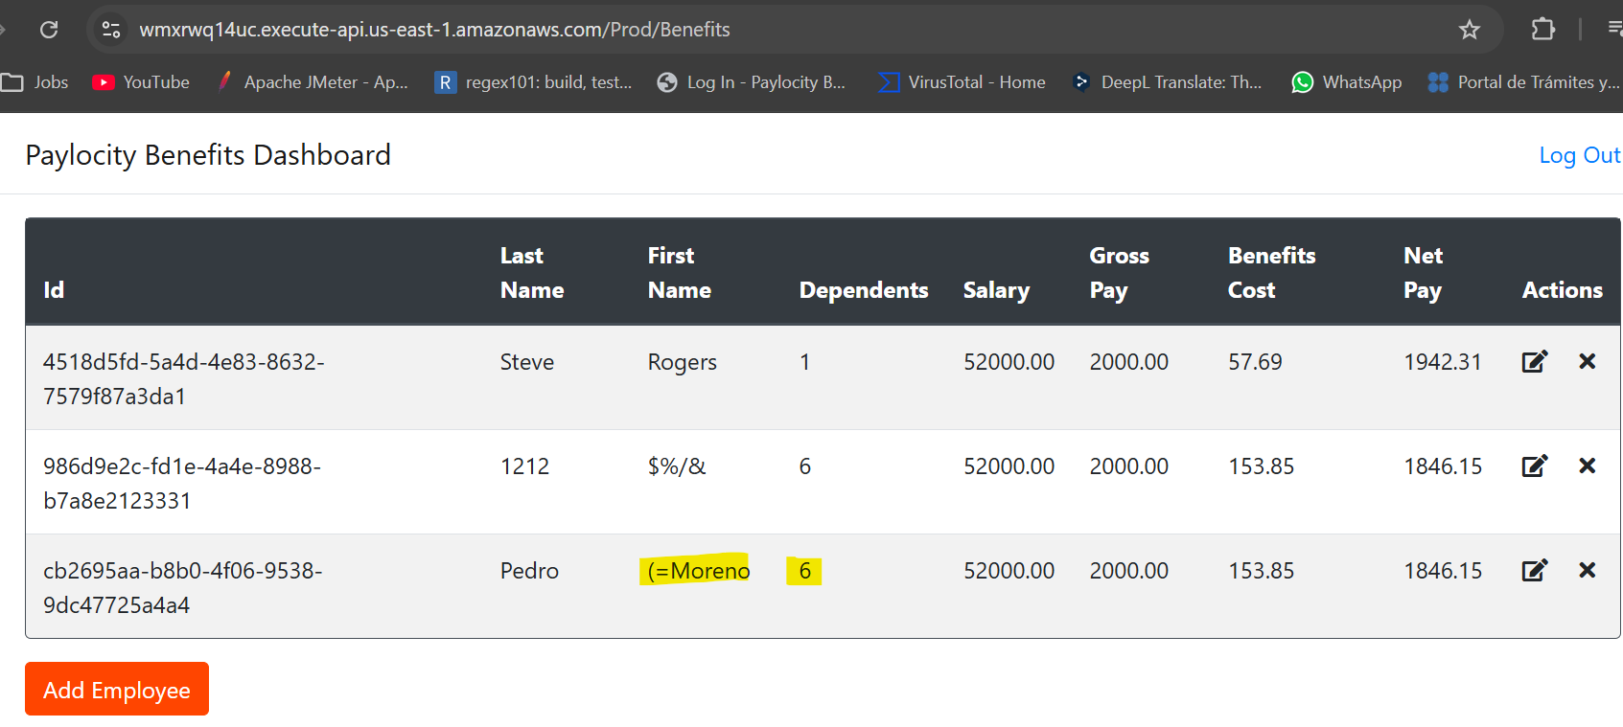

+++++++++++++++++++++++++++++++++++++++++++++++++++++++++++++++++++++++++

Paylocity, Insecure Logout (“sensitive information displayed after closing the session”)

Bug description:
As a final user I would like to keep my sensitive data safe, but after logging out the tool and clicking on going back, in the left arrow of the browser, the whole grid is displayed showing all stored data.

Steps to reproduce the issue:
1.- Log in to Paylocity tool.
2.- Click on Log Out Linktext.
3.- Click on the arrow to go back (Left arrow “<-” of the browser to go back).

Expected Result:
The Login page should be displayed or at least the information should NOT be displayed.

Actual Results:
The grid is displayed showing al the “Sensitive Information”. (Even if you can NOT add/modify/delete employees’ information).
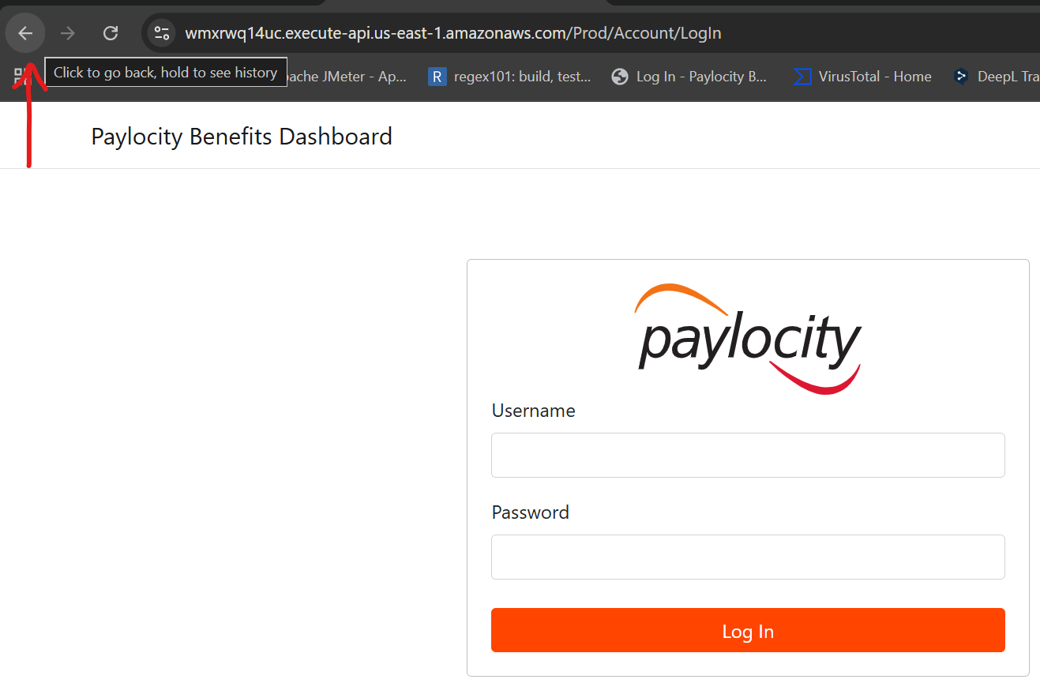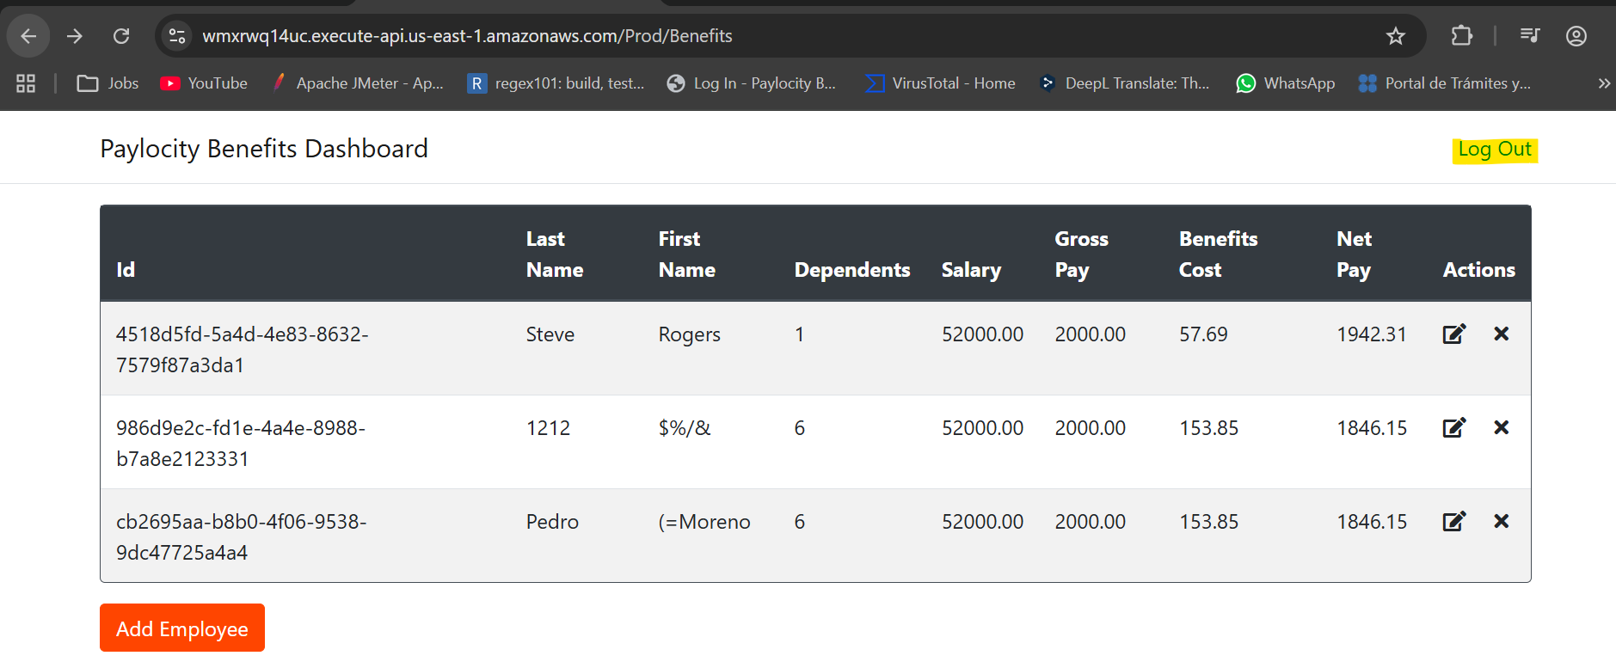
NOTE: if the table is displayed after logging out you can refresh the page and the grid information will disappear but the headers.
++++++++++++++++++++++++++++++++++++++++++++++++++++++++++++++++++
Paylocity, Security bug.

Description bug:
The dashboard is displayed even if you have never logged in before.

Steps to reproduce the issue:
1.- Going to Log in page.
2.- Click on Paylocity Benefits Dashboard Linktext.

Expected Results:
You Should remain on Log in page.

Actual Results:
The dashboard is displayed (Only grid headers, NO data is shown).
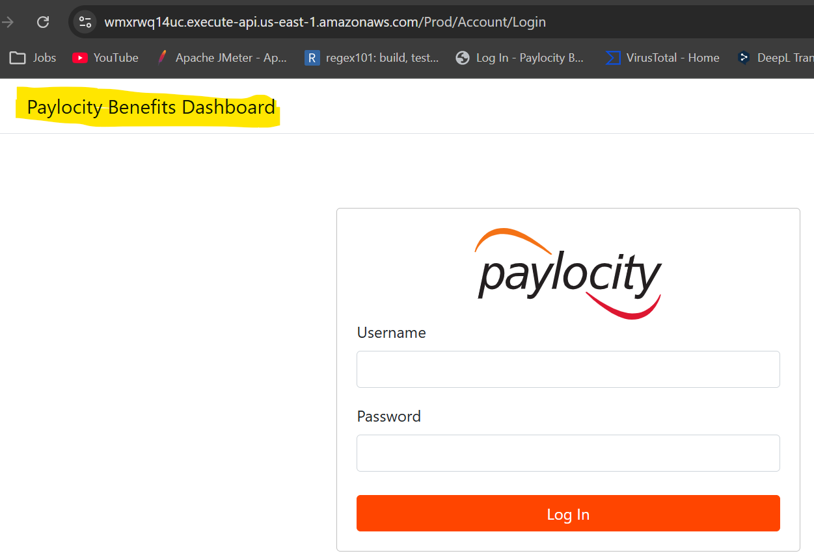
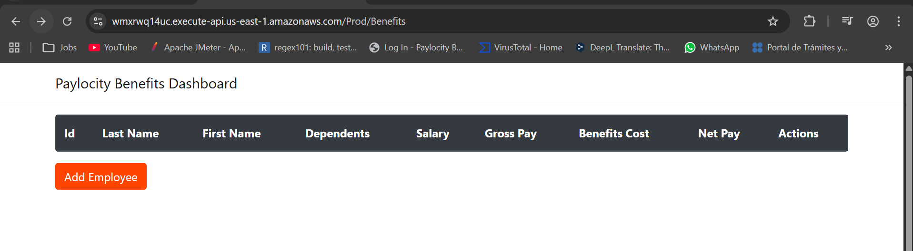
+++++++++++++++++++++++++++++++++++++++++++++++++++++++++++++++++++++++
Paylocity, Incorrect Popup Title (Update popup)

Bug Description:
The updating employee popup displays the wrong title (Add employee instead of Update Employee).

Steps to reproduce:
1.- Log in to Paylocity tool.
2.- Click on Update icon, located in Actions column.

Expected Results:
A popup titled Update Employee will appear.

Actual Results:
A popup titled Add Employee appears.
